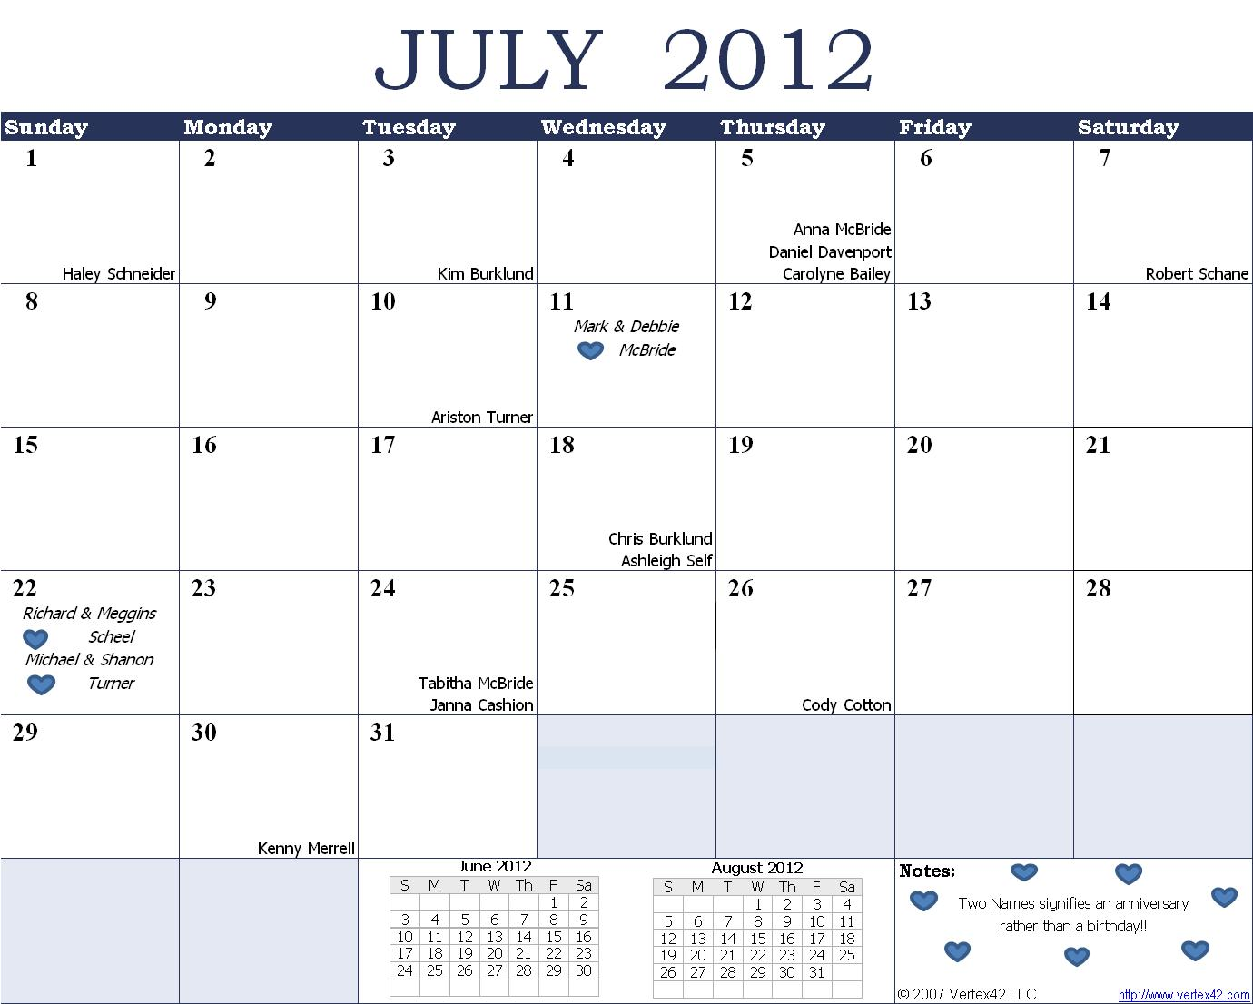

Happy Mother’s Day
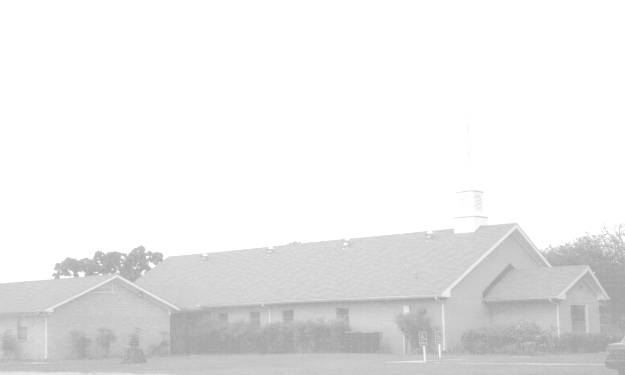

July Newsletter
Knobbs Springs Baptist Church
1662 CR 305
McDade, TX 78650
Please email KnobbsSpringsBaptist@gmail.com to be removed from our mailing list. Thanks!


Non-Profit Organization
U. S. Postage Paid
Permit # 1
McDade, Texas

BAPTIST CHURCH

1662 CR 305

McDade, TX 78650

Phone: (512) 273-2743

Email: KnobbsSpringsBaptist@gmail.com

Pastor
Bro Mark McBride
(512) 229-6555
Txloves2fish@yahoo.com

Other Contacts
Cleyon Davis – Treasurer
(512) 856-2524

Kimberly Tabor – Office Manager
(512) 698-2804

July Ushers
Joe Daniel, Ray Edwards
Daniel Davenport, Mike Turner

July Hostesses
Otisann McManus, Darleen Gravell
Terri Edwards, Dianne Stutes

July Nursery Schedule

1 0-2 Year Olds Debbie McBride
3-4 Year Olds Cherilyn Wilson
Helper Yoli Oliver

8 0-2 Year Olds Cheryl Franklin
3-4 Year Olds Evelyn Robinson
Helper Mickey Stanford

15 0-2 Year Olds Paula Hicks
3-4 Year Olds Karen Cotton
Helper

22 0-2 Year Olds Teresa Schane
3-4 Year Olds Stephanie Goodson
Helper

29 0-2 Year Olds Tami Knipstein
3-4 Year Olds Terri Edwards
Helper

Weekly Service & Activity Schedule:

SUNDAY
Sunday School 9:45 a.m.
Morning Worship Services 11:00 a.m.
Youth Activities 5:30 p.m.
Evening Services 7:00 p.m.

MONDAY
“Work-It-On-Out” 6:30 p.m.

WEDNESDAY
“Work-It-On-Out” 6:00 p.m.
Youth Worship 6:30 p.m.
Wednesday Services 7:00 p.m.

THURSDAY
“Work-It-On-Out” 6:30 p.m.

